MEMORANDUM

TO: Cape Elizabeth Town Council
FROM: Maureen O'Meara, Town Planner
DATE: May 19, 2015
SUBJECT: Land Use Amendments Supplemental information

Introduction

Town staff has received questions from Town Councilors related to public comments received about the Land Use Amendments package. Additional information has been collected and presented below so that all councilors have access to supplemental information.

Many emails have been sent touching on the same issues. Below, issues have been grouped into common themes and additional information has been provided.

Population and housing projections

Several comments have been made questioning the accuracy of population and housing growth projections. Some have suggested developing new population projections.

• Population projections by their nature will not match actual data. Projections are most valuable to indicate trends and the magnitude of trends. The population and housing projections for Cape Elizabeth all predict very little growth and actual data is consistent with this trend.

•The 2007 Comprehensive Plan predicted that the growth rate would decline and it has. The 2007 Comprehensive Plan projected 330 new housing units from 2007-2020, contrasting with 156 dwelling units constructed from 2007-2015. The chart below shows actual new dwelling unit construction from 1990-2020 and the estimated new dwelling units included in the Comprehensive Plan (2007-2020 planning period). The projected number of dwelling units was a simple extension of the average number of units constructed from 1998-2006 (when building permit data was tracked by computer) and an assumed decline. The chart clearly illustrates the "Great Recession" beginning in 2007.

•When the Town Council first asked the Planning Board to start work on the Land Use Amendments in 2009, there was public comment questioning whether more growth would occur. The Town Council commissioned Planning Decisions to update the population projections and that report was submitted to the Town Council in September, 2010. That report concluded: (1) that the 2007 Comp Plan projections were reasonable for their time; (2) that the recession had further depressed the small amount of growth anticipated; and (3) that "the changing age profile of the area population will contribute to internal demand for housing."

•The comprehensive plan compared Cape Elizabeth data with other "comparison communities," including Yarmouth and Falmouth. Drawing comparisons with other communities, and with Cumberland County, is a common practice to provide context. Comparing Cape data with other towns does not equate to a policy choice to become more like comparison communities.

Variety of housing types

Comments have been made that there is no demand for housing to accommodate aging residents.

•Both the 2007 Comprehensive Plan and the 2010 Population projections analysis recognize the growing share of Cape residents that fall into the 55+ age category. The aging baby boomer trend is well-documented at the county, state and national levels. But do Cape Elizabeth 's seniors want an alternative to a single family home? The newest condominium project under construction is Eastman Meadows, with a floor plan designed for the 55+ age group. About 1/2 of the units have been purchased by current Cape residents. There are also several grandparents of Cape residents moving to Eastman Meadows.

•Related to the trend for housing to accommodate seniors, the comp plan included an analysis of the impact on the population as existing housing is resold. Homes sold from September 2004 - August 2005 (158 homes) were examined for number of school age children before and after the sale. Prior to the sale, 30 school age children lived in these homes. After the sale, 116 school age children lived in these homes.

Comments have been made that young singles do not want to live in Cape Elizabeth.

•When the Planning Board discussed the multiplex provisions, they identified young adults as another population group that would benefit from multiplex availability. The comprehensive plan identifies the 18-29 age group as shrinking from 11% of the population in 1990 to 4% of the population in 2020, compared to much higher shares for the county (12%) and the state (11%). While the trend for young adults is to live in urban areas, there is little option for housing in Cape for young adults who do want to live here. The Planning Board has recently heard public comments from young adults who do live here and like it.

Comments have been made that residents with senior housing needs should consider relocating to Mill Creek in South Portland

•Both the 2005 and 2015 public opinion surveys show that residents live here longer than residents in other communities. Providing a variety of housing types allows residents a choice to remain in Cape Elizabeth.

Comments have suggested that senior housing equates to institutional housing.

•The multiplex proposal is not intended to increase the amount of nursing home and congregate care housing available. These housing options currently exist in Cape and no demand for more has been identified at this time. The senior housing discussed is actually multiplex housing that would be available to all age groups, but would be designed to accommodate senior needs, such as one-floor living. By not restricting multiplex housing by age, it addresses another comment that the town has not looked 40-50 years down the road. Keeping options open on what age group will occupy multiplex housing positions the town for long-range population shifts.

A comment has been made that "varied housing is not our strong suit."

•"Single family homes represent over 90% of the town's housing stock, and multi-family 7%" 2007 Comprehensive Plan. Even if all the residential growth is multiplex housing, single family homes will remain by far the dominant residential housing in Cape Elizabeth.

A comment asked if smaller unit housing is in demand and if a ratio has been calculated of how much senior housing is needed.

•As part of the Land Use Amendments, the town contracted with Planning Decisions to assess the market feasibility of a variety of multiplex elements. This study suggested that an incentive to vary the size of multiplex units might be included. Specific quotas of the number of units or size of units have not been developed because the town is not proposing new development. The decision to develop is made by the property owner, and the proposed amendments are intended to shape the development that would otherwise occur into a form that also meets the needs of the town.

Public Opinion surveys

Comments have been made that the 2005 survey response to a question about housing options is determinative.

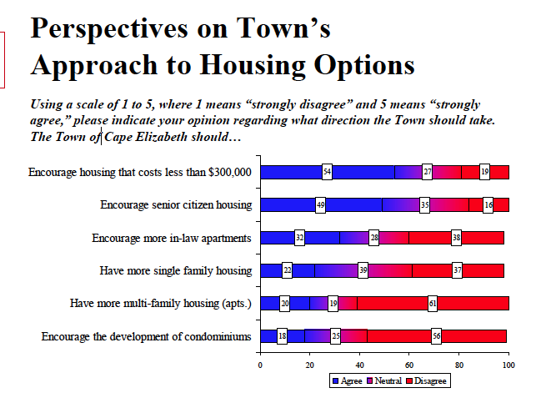

•The comprehensive plan committee spent considerable time discussing the type of survey (telephone v. paper), the questions to be asked, the need for statistically valid results and the conclusions drawn from the responses. A public opinion survey is a very valuable information source for a comp plan committee.

•The Future Open Space Preservation Committee (FOSP), which conducted a statistically valid telephone survey in 2012, also used a public opinion survey as an important component of their final recommendations. In the 2012 FOSP survey (conducted by Critical Insights), 60% of respondents said they were satisfied with the amount of open space in Cape Elizabeth, only 35% said we need more open space protected and less than 1/3 supported increasing taxes to preserve open space. Nevertheless, FOSP recommended that open space preservation and fee ownership purchases continue and the Town Council voted to contribute $350,000 toward the preservation of Robinson Woods II.

Existing regulations

Comments have been made that suggest multiplex development would be new to Cape Elizabeth.

•Multiplex development is currently a permitted use in the residential zoning districts (RA, RB and RC). Multifamily development is permitted in the commercial districts. Condominium developments fall under the multiplex development category. Of the roughly 3,900 dwelling units in Cape Elizabeth, about 350 are condominiums.

•All multiplex development must undergo Site Plan Review by the Planning Board. Site Plan review includes 16 standards of review and include traffic, parking, and buffering. The maximum density allowed in the zoning district will not be allowed if the Site Plan standards cannot be met.

•The current multiplex regulations do not include minimum architectural design requirements for proposed buildings.

Comments have been made regarding the proposed amendment to the Open Space Zoning provisions that allow a variable setback for clustered subdivisions.

•It is common practice for clustered subdivisions to allow some setback variability to maximize open space preservation. Under state law, the Planning Board must be explicitly given this authority by ordinance or cannot use this tool.

Proposed multiplex regulations

Comments have been received opposed to the 50' height proposal.

•The current maximum building height allowed is 35'. This is the height limit for single family homes, commercial structures, and anything except a telecommunication tower, church steeple or similar structure. Generally, a story is about 10', but this can vary, especially on sloped ground where a daylight basement is possible.

•In order to increase the amount of open space preserved on land to be developed, the proposed amendments include a new section that allows for density bonuses. If a development preserves more open space than the 45% proposed (40% right now), then density bonuses are available. There is a maximum cap of 30% over the base density for a bonus. The bonus section also allows some flexibility by allowing a building height of up to 50'. The height increase triggers an increased setback. This new section has been proposed to advance stated town goals, but can be removed if the town decides the open space/density tradeoff is not a good fit for the town.

A comment was made a multiplex development will always preserve more open space that a single family subdivision.

•Depending on the multiplex development, the current regulations may not always require more open space preservation. The ability to preserve open space in large, contiguous parcels with public access is better with multiplex housing, which is one reason the comprehensive plan explored this type of residential development.

Development proposals in the pipeline

Comments have been made regarding conceptual development proposals and the Land Use Amendments package.

•As the economy recovers, and large landowners also enter the 55+ age group, new development proposals are beginning to come forward. The town center proposals are independent of the Land Use Amendments, which primarily address residential development. The town is considering an amendment to the Town Center regarding setback from a village green, which is also separate from the Land Use Amendments. A private development in the vicinity of Hill Way is separate from the Land Use Amendments.

When development occurs

Comments have been made that the town is encouraging developers to come to Cape Elizabeth if these amendments are adopted, that the town is promoting development and that more data should be developed about how much development should occur.

•Development occurs when the private property owner decides to develop property in accordance with local land use laws. The Town of Cape Elizabeth does not have a community development program, and has not set goals for development of a minimum number of dwelling units or square footage of commercial space, as other towns have done.

•Very little development is predicted in Cape Elizabeth. The Land Use Amendments are intended to guide what little development will occur so that the new development best fits the housing needs of the town.

